Subordinating Conjunctions

🔹 What Are Subordinating Conjunctions?
# Source: AI Source: Provided by: [Data Path: Persons Table -> ID Column: 1, Name_En Column: Motasem Essam] -> From: [Chatgpt (GPT-4-turbo)] on [7/28/2025]
Subordinating conjunctions are words that join a dependent (subordinate) clause to an independent clause.
They show the relationship between the two clauses — such as time, cause, contrast, or condition.

✅ Functions of Subordinating Conjunctions
# Source: AI Source: Provided by: [Data Path: Persons Table -> ID Column: 1, Name_En Column: Motasem Essam] -> From: [Chatgpt (GPT-4-turbo)] on [7/28/2025]
They answer questions like:
- When? (Time)
- Why? (Cause)
- How? (Manner)
- Under what condition? (Condition)
- In contrast to what? (Contrast)

🧩 Common Subordinating Conjunctions
# Source: AI Source: Provided by: [Data Path: Persons Table -> ID Column: 1, Name_En Column: Motasem Essam] -> From: [Chatgpt (GPT-4-turbo)] on [7/28/2025]
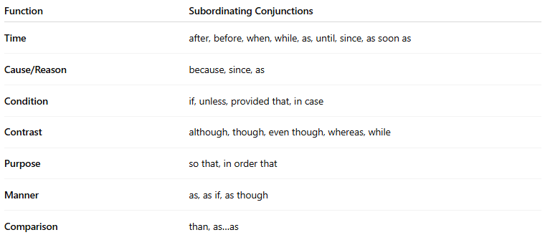
Function | Subordinating Conjunctions
Time | after, before, when, while, as, until, since, as soon as
Cause/Reason | because, since, as
Condition | if, unless, provided that, in case
Contrast | although, though, even though, whereas, while
Purpose | so that, in order that
Manner | as, as if, as though
Comparison | than, as…as

📚 Examples in Sentences
# Source: AI Source: Provided by: [Data Path: Persons Table -> ID Column: 1, Name_En Column: Motasem Essam] -> From: [Chatgpt (GPT-4-turbo)] on [7/28/2025]
- Time: I’ll call you when I arrive.
- Cause: She left early because she was tired.
- Condition: We’ll go out if it stops raining.
- Contrast: Although he’s rich, he’s humble.
- Purpose: She studies hard so that she can pass.

🧠 Important Notes
# Source: AI Source: Provided by: [Data Path: Persons Table -> ID Column: 1, Name_En Column: Motasem Essam] -> From: [Chatgpt (GPT-4-turbo)] on [7/28/2025]
- The dependent clause cannot stand alone.
- A comma is often used when the dependent clause comes before the main clause:
✅ Because it rained, we stayed indoors.
✅ We stayed indoors because it rained. (no comma)

